**Simulator user guide v1.1**

**Abstract**

Both simulator_console and simulator_gui can be used to test your program, however simulator_gui is recommended.

1. **simulator_console**

The aim of this simulator is to help people who cannot access to the internal mainboard to debug their program (Windows only).

1. Download the project and copy the folder “simulator“
2. Download and install visual studio, when install, choose C++
3. Open project “simulator” in visual studio
4. In source file main.cpp, you can test out anything thing with button and LED. Totally 3 buttons and 3 LED can be used. All information can be found in simulator.h if anyone want to dive deep into implementation.
5. Use the namespace simple_mode for easier and short output, complex_mode for detailed output.

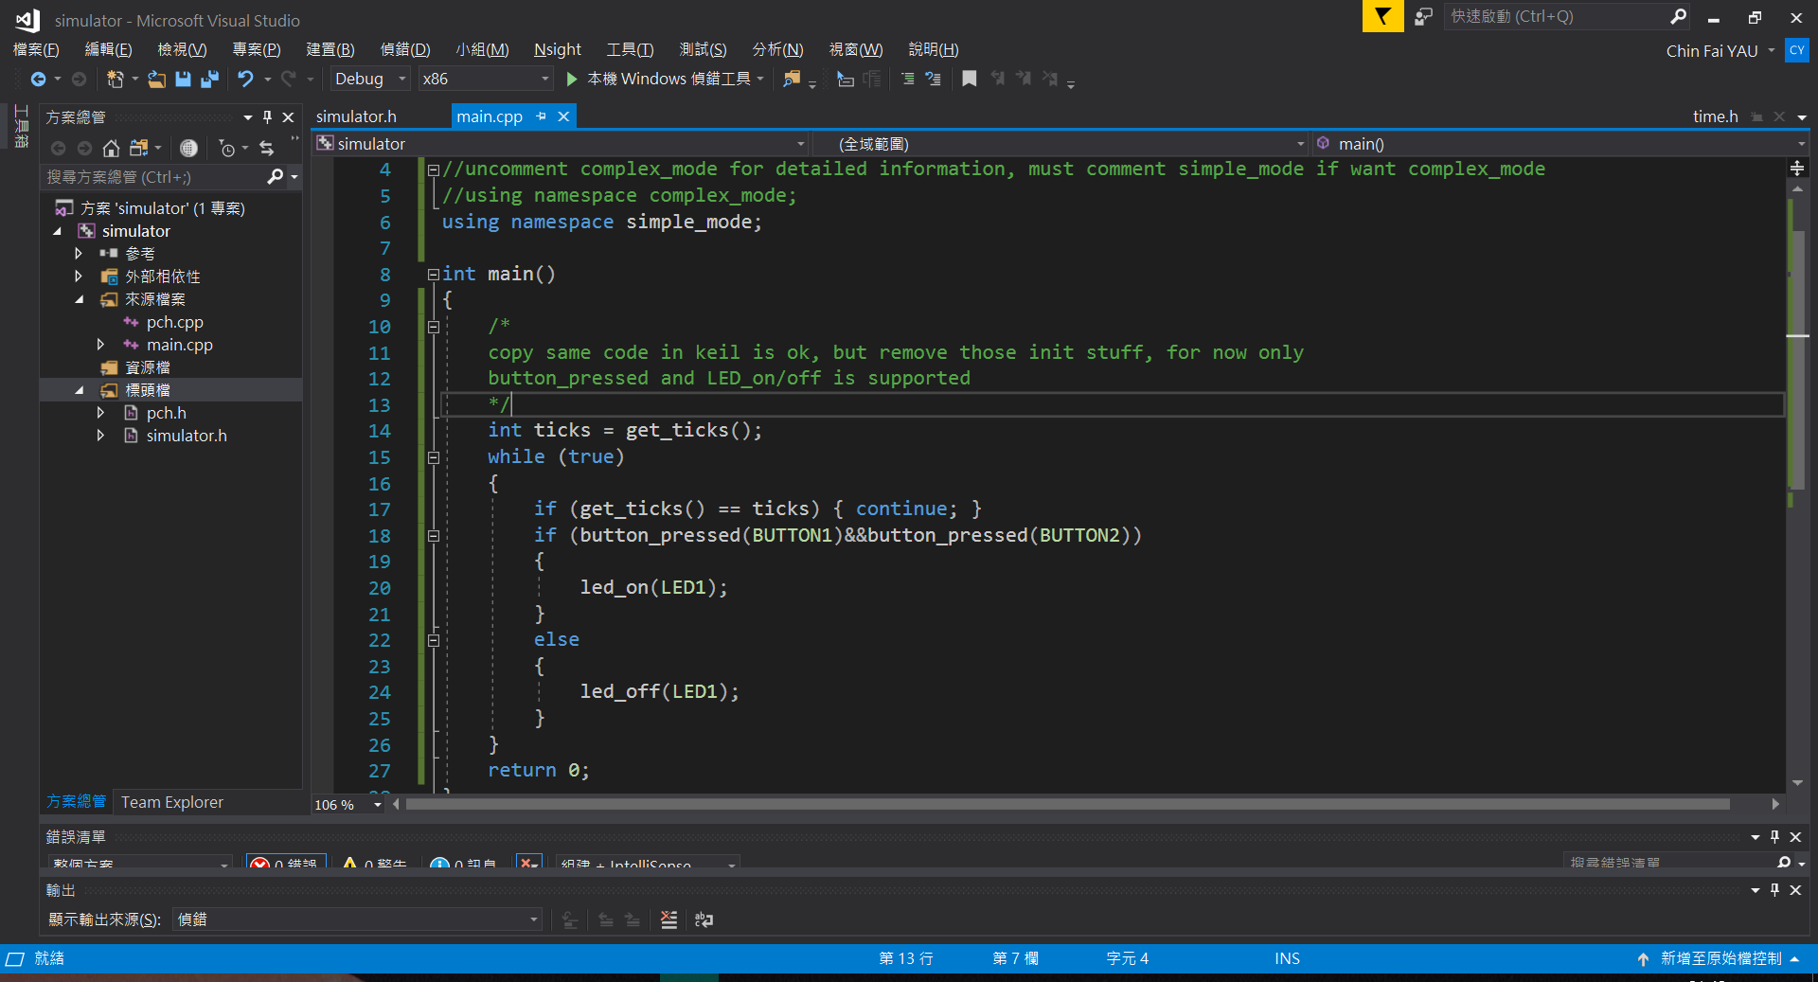

Simple output example:

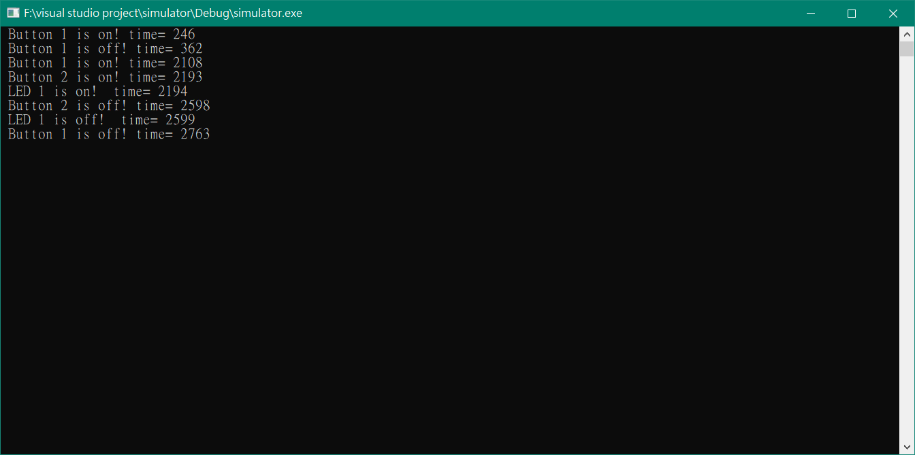

Detailed output: 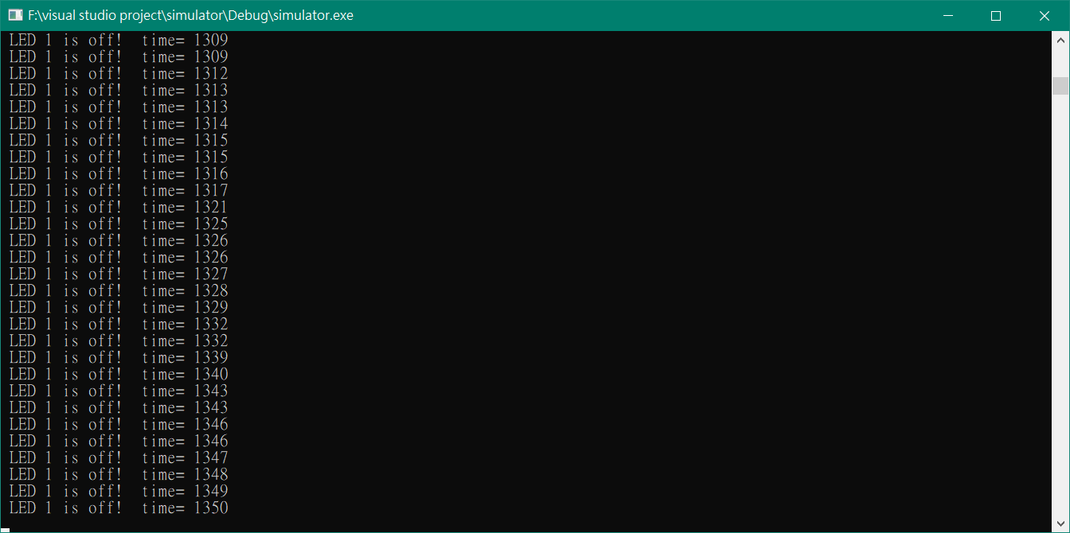

1. simulator_gui
2. Download and install Visual studio 2019 and download Qt. Choose MSVC 2019 when you install Qt options.
3. Copy and paste your code into roboticswork.h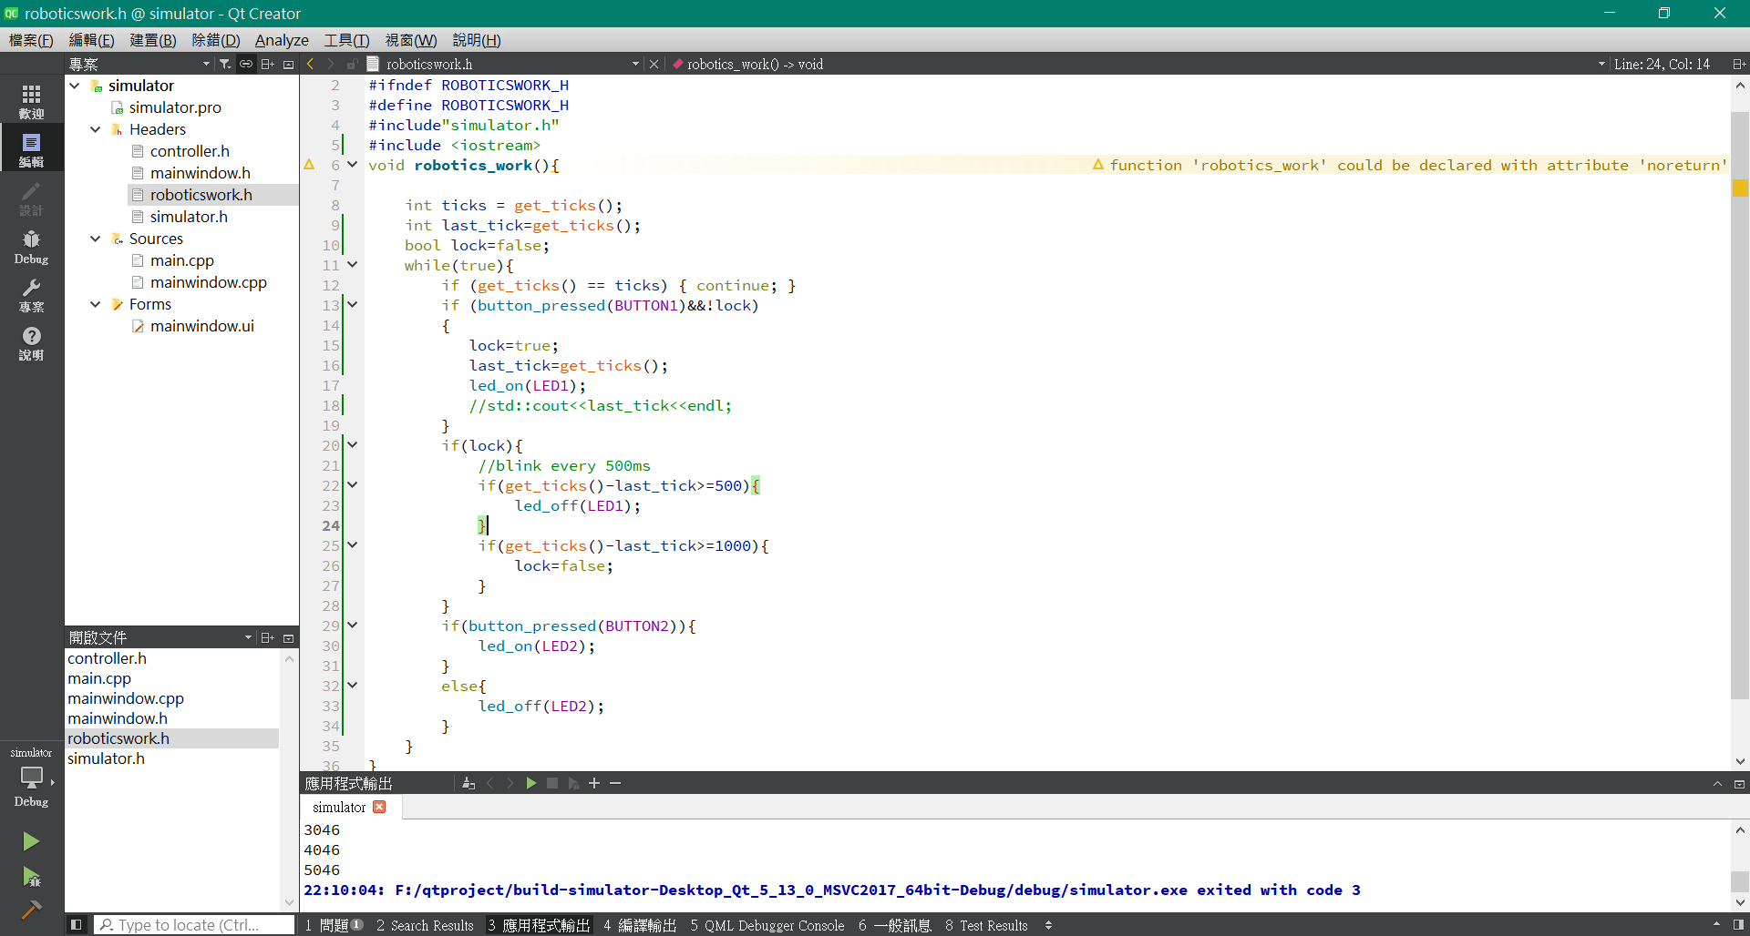
4. **Clean the project and rebuild. (MUST DO)**
5. 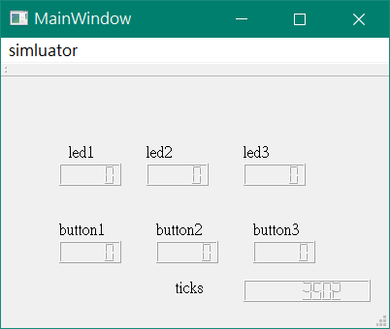
6. Totally 3 buttons and 3 led are supported. Also, a tick count to indicate is program dead.
7. Press keyboard key 1/2/3 to simulate button press.
8. The program shows 1111 if on, 0 if off.